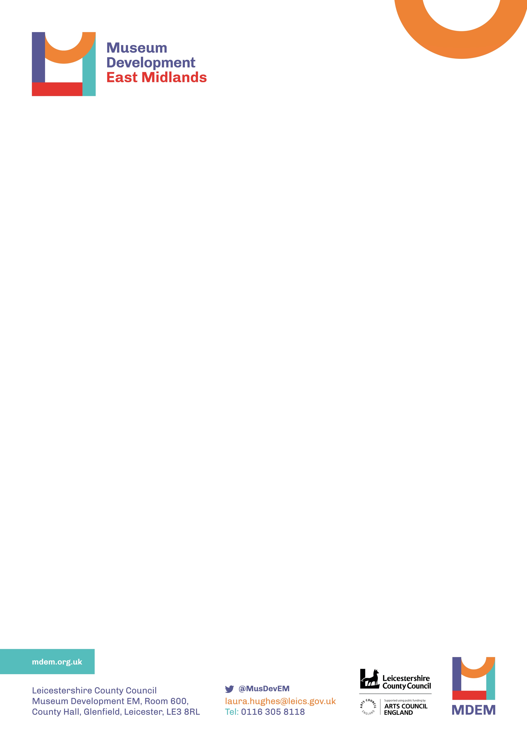
SMALL GRANTS FUND 2021-22
Grant Application Form and Guidance

Museum Development East Midlands (MDEM) is funded by Arts Council England. Small Grants are assessed on a monthly basis by a grants panel that includes Arts Council representation. Applications can be made between 1 April 2021 and 31 January 2022 and it is a competitive process.

What the grant can fund: Purchase of equipment and materials; training costs; match funding towards a purchase/ project/ short term temporary contract to e.g. advise or support an activity, project or development. Grants cannot fund revenue (running) costs or building work.

Eligibility: Applicants must be an Accredited Museum or with ‘Working Towards Accreditation’ status. Provisionally accredited museums are eligible to apply.

Over the coming year (2021-22) all successful museums must complete the MDEM Organisational Health Check. This helps MDEM identify areas of need and enables MDEM to understand where investment helps support longer term strategic/ organisational development.

Your application will be assessed against the following criteria:
- Project is viable, achievable and clearly planned. There is a demonstrable need.
- Urgency of need and availability of other suitable funds
- Outcomes of project align with museum’s Forward Plan and will make a significant difference to an aspect of the museum’s operation.
- Project meets one or more of the Arts Council’s Goals.
- Project demonstrates value for money.
- Application demonstrates 10% match funding towards total project cost
- Grant enables improvements related to the requirements of Museum Accreditation.
- Project is informed by MDEM support / recommendations.

Match funding: MDEM can fund up to 90% of the total project costs – applicants must demonstrate how they will cover the remaining costs. A match funding contribution can be in cash and/ or volunteer-time where appropriate (see application form).

How much can you apply for: £250 - £1,500 per annum

When is the deadline? Museums can apply at any time, applications will be assessed at the end of each month between April and January (to meet this deadline, applications must be received by the end each month). You will receive notification of the outcome of your application within two weeks of the assessment. If you are successful you will need to accept the Small Grant Terms and Conditions issued with your offer letter before payment can be made. We should be able to make grant payments within six weeks of receipt of acceptance of terms and conditions.

More information: If necessary, discuss your application with the MDEM programme manager in advance of submission – claire.browne@leics.gov.uk

You can find information about our Privacy Policy here.

Museum Commitment: By applying for a grant you are acknowledging that you will provide MDEM with grant monitoring and evidence of expenditure information, and that you will complete the annual regional data survey and Organisational Health Review when requested.

Handwritten applications are not accepted.

1.Name of organisation:

2.Museum Accreditation Number:

Or, do you have ‘Working Towards Accreditation’ status with Arts Council England? YES/ NO (delete as appropriate)

3.Contact person for this application:

Name:

Position:

Tel:

Email:

4.Please provide a headline summary of the project/ activity for which you are seeking funding (max. 25 words):

5.Amount of grant requested:

6. Grant payment:

The grant will be paid by bank transfer – please complete the attached BACS form and send a copy of your bank paying-in slip.

7. Please tell us why you need this funding and how the proposed project/ activity relates to your forward plan (max. 250 words):

8. If you receive the grant, please tell us what the outcomes will be for your museum/ how the grant will make a difference (max. 250 words):

9. Please provide a breakdown of project costs and suppliers:

10. What is the total project cost? (where volunteer time is included in the total project cost please show the hourly/ daily rate you have used in your calculation)

11. How much is your match funding contribution to this project? This must be a minimum of 10% of the total project cost and could include volunteer time if included in the total project cost calculation in Question 10.

12. How do you intend to source the match funding?

13. First signature (by person completing the application):
I certify that, to the best of my knowledge, the information given in this application is correct:

Signed: Date:

Position:

Email:

14. Second signature (someone different in your organisation from the person who completed the application form):
I certify that, to the best of my knowledge, the information given in this application is correct:

Signed: Date:

Position:

Email:

Should you wish to discuss your application in advance of submission, contact Claire Browne, Museum Development Manager Tel: 07973 800072 or email: claire.browne@leics.gov.uk

Please email your completed form marked ‘Small Grant Application’ to:
Laura Hughes, Museum Development Project Officer laura.hughes@leics.gov.uk

Thank you for making an application. You will receive confirmation of receipt of your grant application by return email – please contact Laura Hughes (as above) if you do not receive a receipt (first week of each month) within one week of submission. You will be notified of the outcome of your application within two weeks of the next grant panel meeting.

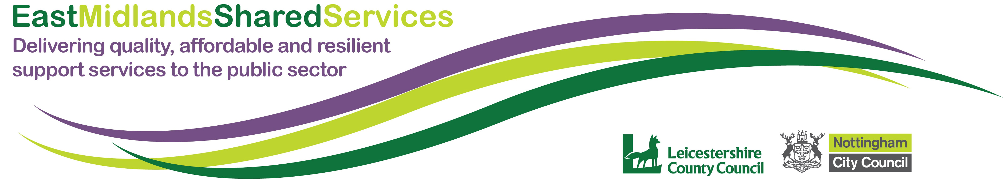

BANK DETAILS FOR BACS PAYMENTS

The details provided on this form will be held in our financial system and be used to make payment to the payee detailed in the below fields.

Payee Information

Name

Address

Telephone Number

Email Address for Remittances

Bank Account/Building Society Details

Name of Bank or Building Society

Branch Name

Sort Code

Account Number

Account Name

Roll Number
(required for Building Society Accounts)
Verification of Details
To prevent any fraudulent activity, we require either a paying-in slip or a bank statement to support your bank mandate submission. If submitting a bank statement, values can be blanked out.

Payee Signature

Date

Verification Provided | Paying-in Slip Bank Statement

Please scan and email the completed form to the department contact that issued this document to you.

