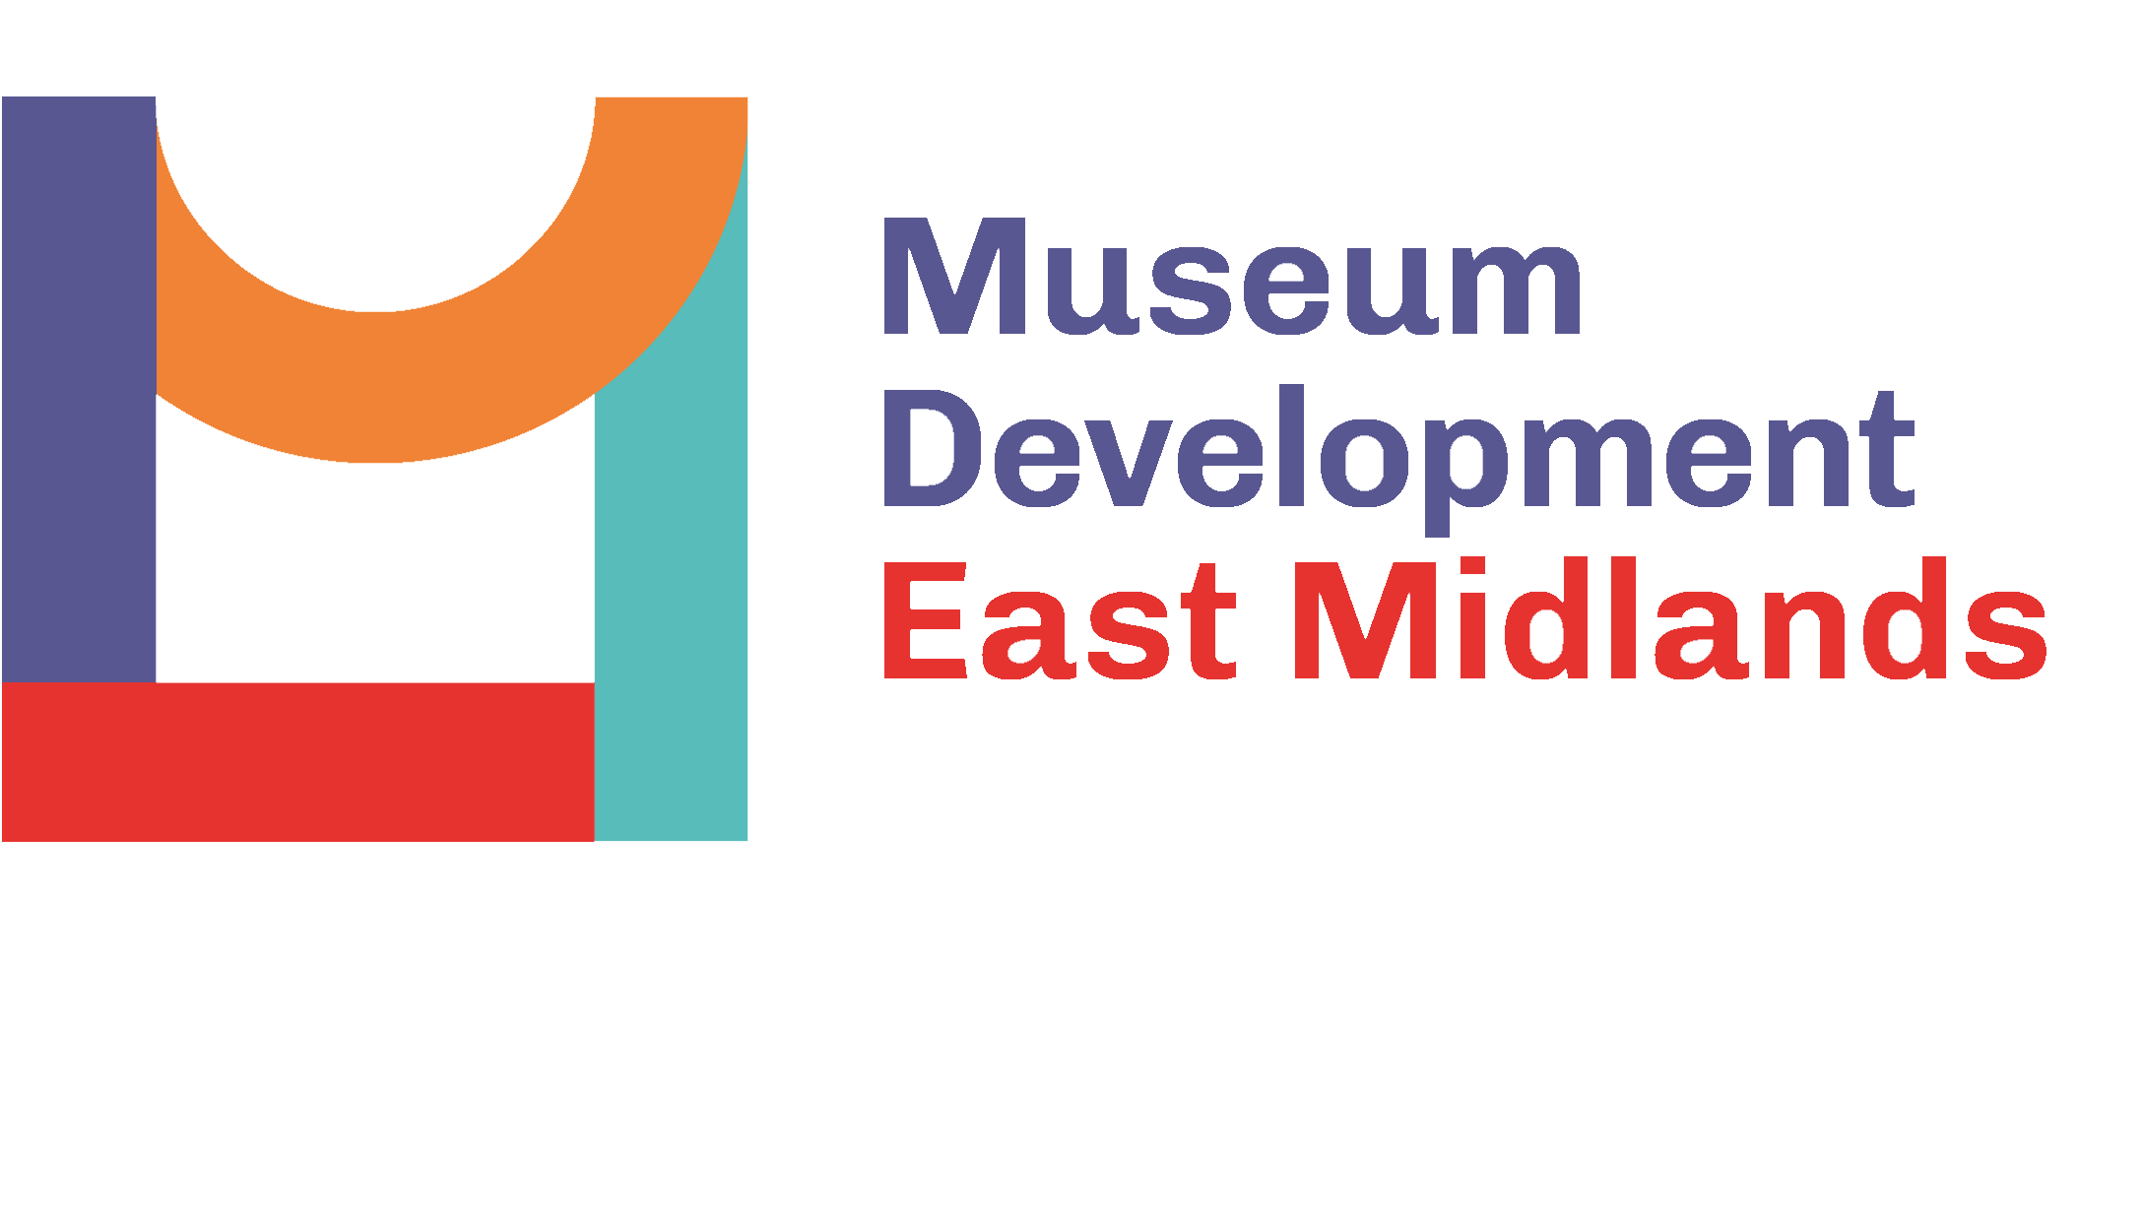
New Narratives 2023
Expression of Interest

Organisation:

Programme Lead name: Role:
Additional delegate: Role:
Additional delegate: Role:

Emails of all the above:

1) Please describe the Collection which you would like to develop new narratives on?

2) What are the current barriers you face to developing work in this area?

3) What are you hoping to gain from the programme?

4) Please outline the way/s that joining this programme will enable your museum to become more inclusive?

2) Are you committed to participating in three programme sessions, up to three training sessions and ongoing facilitated sessions with MDEM? See Programme information for dates and further information
-An in person introductory programme meeting 19th April
-Mid-point online sharing event 12th July
-An in-person end of programme sharing session with other programme delegates – 31st October
-Up to 3x online programme training sessions (dates and times tbc)
-Ongoing programme discussions with Facilitator Anita Hollinshead

DELETE AS APPROPRIATE: YES / NO

Please note: only Accredited Museums or those working towards Accreditation from the East Midlands are eligible to apply and have already submitted your Organisational Health Check 2022.

All programme museums are subject to MDEM’s Terms and Conditions to complete the Annual Museums Survey 2023 and provide case studies when requested. Do you agree to these terms? YES/NO

Data processing: MDEM collects the data on this form to ensure it can deliver the programme to it’s fullest for participating organisations. This data may at times be shared with other consultants contracted by MDEM to fulfil an element of this programme or for evaluation purposes. Do you agree to your data being used in this way? YES/NO

You can see our full data policy here including details of how to request your data.

Signed by (We will accept electronic signatures):
Programme Lead:

Project Sponsor (member of the governing body):
Date:

Please note the closing date for expressions of interest is 24th March 2023. Please return this form to sarah.hartshorne@leics.gov.uk . Organisations will be notified of the outcome by the 30th March.

