How to use this Emergency Plan template…

- Instructions are in blue italics

- Words/ sections highlighted in yellow are where you should insert information appropriate for your site

Your emergency plan should be an ongoing working document, updated and reviewed regularly and it is essential that staff and volunteers are aware of the content of the plan and know what to do in the case of an emergency. The plan should be referred to for all types of emergencies – from a small leak to a full scale incident.

This template is designed for you to adapt and amend to meet your own set of circumstances. It has been developed in line with the Accreditation Guidance (Arts Council England, 2019) which requires museums to have ‘A clear, workable emergency plan’ in order to meet the standard.

The guidance states that your emergency plan should be appropriate to the size of your museum and the composition of your collections and should include:
- Arrangements for the staff and volunteers, visitors, collections and collections information
- A risk assessment of threats
- Information on how the plan is authorised, maintained, communicated, tested, and made available to your staff and volunteers and the emergency services.
- How your plan links to any other relevant emergency plans, for example if you share a building with another organisation
- An understanding of salvage priorities and information on first aid steps for damaged objects
- A review procedure and date of review

Along with the Accreditation Guidance; the plan has been based upon the Spectrum 5.0 procedure for emergency planning for collections, a template provided by East Midlands Museums Service (EMMS); ‘Be prepared: emergency planning toolkit for museums’ (Norfolk Museums & Archaeology Service/ Renaissance East of England, 2008) and resources on the ‘Emergency Response Plans’ web pages (Historic England, 2020)
You might find it helpful to separate out the sections of the plan that you will need in the actual event of an emergency so they can be easily accessed. Two possible ways of doing this would be to use coloured dividers in your Emergency Plan folder or using different coloured printer paper for the priority sections – use whatever works best for your site.

EMERGENCY PLAN

FOR

NAME OF MUSEUM

Postcode:  Grid Reference: | INSERT POSTCODE  INSERT GRID REFERENCE
Copy number (1) of (5)

Responsibility of the Curator and Manager

To be kept at: the Office at NAME OF MUSEUM
If applicable, insert a hyperlink to where the plan is stored on a shared drive

CONFIDENTIAL – if found please return to:

NAME OF MUSEUM
ADDRESS OF MUSEUM

Telephone: INSERT TELEPHONE NUMBER
Email: INSERT EMAIL ADDRESS

Date of issue/ or last review:  Date to review contents: |  | INSERT DATE  INSERT DATE`
What to do in an Emergency – how to respond to specific emergency situations is described in the following table:

The safety of visitors, volunteers and staff is of paramount importance and must be the priority – if an emergency happens during opening hours, follow the normal fire evacuation procedure (ref. page ///) if necessary and make sure all people are accounted for.

Call 999 for emergency services

Call the Emergency Co-ordinator and other members of the team as needed.

Collect the emergency kit from the INSERT LOCATION if team are not wearing PPE.

Take advice from emergency services as applicable then conduct a risk assessment (ref. template on page ///)

The risk assessment must be undertaken before any salvage operation can begin in order to ensure it is safe to go ahead.

Consult risk assessment and decide the best way forward bearing in mind the need to make the site safe and secure and to remove any priority items from affected areas.

Contact service suppliers (ref. Section 5.2 on page //)

Remember to document what has happened and is happening – this will be required for any insurance claims that have to be made.

Contents:
The sections highlighted in green probably won’t be needed during an actual emergency so you might want to separate them out somehow (such as colour coded paper or dividers) – adapt the template to suit your site’s needs
 |  |  |  |  |  | Page
1. |  | Introduction
 |  | 1.1 |  | Definition of an emergency
 |  | 1.2 |  | Aim of the Emergency Plan
 |  | 1.3 |  | Emergency Plan availability
 |  | 1.4 |  | Location of salvage and treatment areas
 |  | 1.5 |  | Emergency Services
 |  | 1.6 |  | Updating
 |  | 1.7 |  | Testing
2. |  | Evacuation Procedures
3. |  | Risk Assessment of Threats
4. |  | Fire Risk Assessment
5. |  | Emergency Contacts
 |  | 5.1 |  | Emergency Response Team
 |  | 5.2 |  | Contacts for emergency services, insurance, alarms and utilities
6. |  | Emergency Response Team roles
7. |  | First Aiders
8. |  | What to do in case of…
 |  | Accident
 |  | Assault
 |  | Bomb threat
 |  | Fire
 |  | Flood/ water leak
 |  | Gas leak
 |  | Illness
 |  | Missing person
 |  | Oil leak
 |  | Pest infestation
 |  | Poisoning
 |  | Security risk (e.g. broken window or door)
 |  | Storm damage
 |  | Theft/ burglary
 |  | Vandalism
 |  | Vehicle crash
9. |  | Prepared press statement and key contact information
10. |  | Site/ Floor Plans
11. |  | Salvaging Objects
 |  | 11.1 |  | PRIORITY OBJECTS
 |  | 11.2 |  | Other Objects
 |  | 11.3 |  | Challenging Objects
12. |  | Priority Object Grab Sheets
13. |  | Risk Assessment Form for Emergency Situation
14. |  | Inventory of Salvaged Objects/ Damage Record Form
15. |  | Incident Assessment Form
16. |  | Salvage
 |  | 16.1 |  | Documentation
 |  | 16.2 |  | Priority Objects
 |  | 16.3 |  | Other Objects
 |  | 16.4 |  | Labelling Objects
 |  | 16.5 |  | Security
 |  | 16.6 |  | Salvage Kit
17. |  | Local facilities and sources of equipment
17. |  | National salvage suppliers
19. |  | Handling and treating objects
 |  | 19.1 |  | Handling and moving objects - guidance
 |  | 19.2 |  | First Aid Treatment – Air Drying
 |  | 19.3 |  | First Aid Treatment – Freezing
 |  | 19.4 |  | First Aid Treatment – Mould
 |  | 19.5 |  | First Aid for different collections materials: include materials that are relevant to your collections
 |  |  |  | Books
 |  |  |  | Ceramics and glass
 |  |  |  | Furniture
 |  |  |  | Leather
 |  |  |  | Metal
 |  |  |  | Natural History
 |  |  |  | Paintings
 |  |  |  | Paper
 |  |  |  | Photographs
 |  |  |  | Plastics
 |  |  |  | Stone
 |  |  |  | Textiles
20. |  | Guidance – Entering a Flooded Building in Safety
21. |  | Guidance - Spillages
22. |  | Guidance - Pandemic
23. |  | Emergency Plan Review Procedure
APPENDIX 1: Forms to copy and use
*Risk Assessment Form for Emergency Situation
*Inventory of Salvaged Objects/ Damage Record Form
*Incident Assessment Form

APPENDIX 2: Building Checklist

This plan is based upon the Accreditation Guidance (Arts Council England,2019); the Spectrum 5.0 procedure for emergency planning for collections, a template provided by East Midlands Museums Service (EMMS); ‘Be prepared: emergency planning toolkit for museums’ (Norfolk Museums & Archaeology Service/ Renaissance East of England, 2008) and resources on the ‘Emergency Response Plans’ web pages (Historic England, 2020)

1 | Introduction
You should begin the emergency planning process by considering and assessing the threats to your museum/ heritage site. Museum Development East Midlands has developed a ‘Template Risk Assessment of Threats for Museums’ you can adapt and use for this along with a leaflet ‘What are the Risks to Museums?’. Both can be downloaded along with a number of other resources to help you with your emergency planning here

You might also find it useful to complete the Emergency Preparedness section of Benchmarks in Collection Care
1.1 | Definition of an emergency
An emergency is any incident which threatens human safety and/ or damages or threatens to destroy the museum’s buildings, collections, contents, facilities or services. Common threats include…

Risks to people:
- Hazardous materials
- Injuries (slips, trips and falls)
- Heavy lifting
- Safeguarding (children and vulnerable adults)
- Lone working
- Pandemic

Risks to the building/ collection:
- Flood/ water ingress
- Fire
- Theft
- Breakages
- Pests (insect and rodent)
- Cold temperatures
- Mould
- High winds
- Blocked chimney
- Vandalism
- Inappropriate cleaning/ conservation
- Power cut
- Pandemic

Risks to the organisation:
- Data breach
- Lack of staffing
- Lack of business plan
- Lack of business continuity plan
- Lack of succession planning
- IT systems failures
- Pandemic
1.2 | Aim of the Emergency Plan
This plan details procedures and guidelines to be followed in the event of an emergency, enabling the Emergency Management Team (EMT) to act swiftly to minimize damage to the buildings and their contents.

The museum is committed to ensuring the safety and security of its staff and the public at all times; risk management has been carried out.

At no stage is any member of staff or volunteer expected to put themselves in danger in a salvage situation. The museum will ensure that health and safety is properly assessed and adequate personal protective equipment (PPE) is provided.
1.3 | Emergency Plan availability
Copies of the Emergency Plan are kept in the INSERT LOCATION. A further three copies are held at home by
- NAME (Emergency Coordinator)
- NAME (Deputy Building Recovery Manager)
- NAME (Salvage Recovery Manager)

All trustees and staff have access to a summary of the plan on the shared Google drive. All staff and volunteers have a copy of the emergency plan handbook with confidential and personal information redacted.

Note that these plans contain confidential information about personnel and exhibits.
1.4 | Location of salvage and treatment areas
In the event of an emergency; the area that would be used for placing and treating salvaged collections would be INSERT NAME OF SALVAGE AND TREATMENT AREA/S HERE

Describe the salvage and treatment area including size of rooms and distance from the museum – consider including a map of the location. Ensure that your museum has an agreement with the owners of the salvage and treatment area that allows you to use/ hire the space in the event of an emergency. Include relevant contact details for the use of the space within your emergency plan.
1.5 | Emergency Services
 | Describe how the museum works with the emergency services here
1.6 | Updating
This plan was issued in INSERT DATE. The plan will be reviewed every five years by INSERT ROLE E.G. CURATOR and immediately after any significant changes to buildings and contents such as a redevelopment.

The emergency plan will be reviewed and revised as appropriate in response to any emergency situation at the museum. The principle areas to review are contact details for personnel and the location of objects.
1.7 | Testing
The emergency plan will be tested annually and updated in line with any matters arising from the test.

You should create a log to record when the emergency plan is tested. This could be included within the plan so that it is easy to locate and complete.
 | Emergency Plan Testing Log
 | date |  | comments | actions |  | signed
2. | Evacuation Procedures
 | Describe your evacuation procedures here. This Emergency Evacuation Procedures sign example is from Historic England.
 | Emergency Evacuation Procedures
IN CASE OF FIRE OR OTHER EMERGENCY:

- Raise the alarm by breaking the nearest fire alarm break-glass call point
- Evacuate the premises by the nearest route
- Tackle the fire, if safe to do so, without taking any risks.
- Call the Fire and Rescue Service by dialling 999

ON HEARING THE ALARM

- Evacuate the premises by the nearest route
- ensure that disabled people are helped to safety
- Report to the assembly point at

 |  | MAIN CAR PARK
DO NOT

- Do not stop to collect personal belongings
- Do not re-enter the building until authorised to do so
- Do not use lifts unless disabled & lift is checked and declared safe to use.

3. | Risk assessment of threats
 | A risk assessment of threats to the museum was undertaken and used to inform the review of the Emergency Plan. It was based upon the template developed by Museum Development East Midlands (MDEM) in February 2020.

Organisation: |  | Assessor’s name and role:
Date of assessment: |  | Next review date:

What are the Hazards? | Best practice | Comments on this - including your current provision and further actions needed | Who will carry out the actions needed | Projected Completion Date
Fire
Fixed wiring | The organisation has a 5 yearly fixed wiring test and undertakes annual visual checks
Electrical Safety | PAT testing is routinely undertaken
Electrical safety | Sockets are not overloaded, and wires are kept neatly
Fire Detection | Fire Alarm systems are installed and regularly tested and serviced
Building fire | Fire Doors are in place and not obstructed
Localised Fire | Fire extinguishers are in place and in date
Localised Fire | Staff and volunteers have received training in using a fire extinguisher
Building Fire | There is a clearly written fire evacuation procedure which staff are trained in
Building Fire | The fire evacuation procedure is tested regularly and recorded
Contractor Management | Hot works licenses are in place for any on-site hot works
Open flames management | Any open flames are managed - for example open-fires are swept
Flammable Materials | Any flammable material stored on site is kept in fire protective storage and risk assessed separately
Other Fire Hazards | List any other potential fire hazards specific to your organisation and how you can mitigate against them
Water
Water ingress | Gutters are regularly cleaned, and drains checked for blockages
Water ingress | Visual checks are regularly carried out in at risk areas, including burst pipes due to adverse weather
Open water | Appropriate safety measures are in place for areas of open water e.g. Lake
Flood | When the building is at risk of flooding there are plans in place to safeguard the collection
Flood | There is an understanding of where localised flooding can occur and preventative measures in place such as sandbags
Other water hazards | List any other potential water hazards specific to your organisation
Environmental Hazards
High Winds | A high winds policy is in place
High winds | There are tree maintenance plans for sites with gardens/grounds
Cold | Buildings are checked for mould infestations. Where these infestations occur, protective clothing is available for cleaning and management
Cold | There are procedures for staff working in cold environments for prolonged periods
Lightening | Lightening conductors are maintained (where applicable)
Extreme temperatures | Collections areas are monitored for significant changes in RH and temp to safeguard collections
Pest Damage | There is a Care and Conservation plan for collections including general housekeeping and maintenance to mitigate pest infestations
Toxic Substances | All toxic chemicals kept on-site (including collections/cleaning etc.) have the appropriate documentation (COSHH/ IOSH) and risk assessments. They are stored in secure locations and clearly marked
Toxic Substances | Where hazardous materials are present in collections they are clearly labelled, stored or displayed appropriately and details included in documentation records.
Other adverse weather hazards | List any other potential adverse weather hazards specific to your organisation and how you can mitigate against them
Security
Collections Theft | A risk assessment of security arrangements is in place - collections audits are regularly undertaken
Physical Assets Theft | A risk assessment of security arrangements is in place - security arrangements are made such as for donations boxes
Other Theft - such as copyright/ IP | A risk assessment of security arrangements is in place - there is a policy on managing copyright and Intellectual Property held by the museum
Cause motivated vandalism | A risk assessment for sensitive programming is undertaken - such as political exhibitions.
Cause motivated protest | A risk assessment is undertaken for planned protests. There is a procedure in place for managing this if it is a probable activity
Other vandalism | A risk assessment of security arrangements is in place - there are appropriate security measures such as CCTV
Collections Data Breach | Accession registers and collections databases are backed up with a copy stored in a fire proof location
Sensitive Data Breach | GDPR training and guidance is given to all staff. All sensitive data is managed to GDPR standards e.g. Password protected
Terrorism | Evacuation procedures for the building are in place and regularly tested
Cyber Attack | Contingency plans are in place for when computer systems are compromised. A paper copy of the accessions register and Emergency Plans are kept on-site in a secure location
Lone Working | There is a lone working policy for the organisation which safeguards individuals
Safeguarding | There are safeguarding policies and procedures in place, regular training is given in this area.
Other security hazards | List any other potential security hazards specific to your organisation and how you can mitigate against them
Emergency Preparedness
Emergency Plan | Your organisation has a written Emergency Plan which includes steps to be taken in an emergency, measures to salvage the collections, emergency telephone numbers, the location of supplies that might be needed in an emergency and floor plans of buildings.
Dissemination of Plan | Every member of the team is trained in emergency preparedness appropriate for their role
Dissemination of Plan | Agencies such as the fire brigade and police liaisons are provided with a copy of the plan
Emergency Plan | Hard copies of the plan are kept in a fire and flood proof location
Emergency Plan Review | The plan is up-to-date and reviewed annually - including updating emergency contact details
Emergency Plan Testing | The Emergency Plan is tested annually – various scenarios are considered
Emergency Salvage | You have identified high priority objects and documents that would need to be salvaged in an emergency and created salvage procedures
Emergency Salvage | You have an ‘essentials’ emergency salvage kit which is maintained on-site and/or awareness of where you can access support in this area in the case of an emergency
Other Emergency Preparedness Hazards | List any other potential emergency preparedness hazards specific to your organisation and how you can mitigate against them

4. | Fire Risk Assessment
It is a legal requirement (Regulatory Reform (Fire Safety) Order 2005) to have a Fire Risk Assessment and to ensure that it is regularly reviewed and updated. Further details can be found here

The London Fire Brigade has some helpful information on fire safety in heritage and historic buildings on their website.

Insert a copy of your Fire Risk Assessment here including the date of the assessment and the review date.
5. | Emergency Contacts
 | Phone all numbers in red first or their deputies if the primary contacts cannot be reached. Emergency Contacts will need to be regularly updated. During the Covid-19 pandemic these need to be updated to take account of staff/ volunteers who are shielding, furloughed or unable to travel.
5.1 | Emergency Response Team: adapt roles to meet the needs of your museum
 | Name | Role | Phone number
 | INSERT NAME | Emergency Co-ordinator | INSERT NUMBER
 | INSERT NAME | Deputy Emergency Co-ordinator | INSERT NUMBER
 | INSERT NAME | Building Recovery Manager | INSERT NUMBER
 | INSERT NAME | Deputy Building Recovery Manager | INSERT NUMBER
 | INSERT NAME | Salvage Recovery Manager | INSERT NUMBER
 | INSERT NAME | Deputy Salvage Recovery Manager | INSERT NUMBER
 | INSERT NAME | Service Continuity Manager | INSERT NUMBER
 | INSERT NAME | Deputy Continuity Manager | INSERT NUMBER
 | INSERT NAME | Safeguarding Lead | INSERT NUMBER
 | Other Emergency Response Team members who can be contacted if need be:
 | Name |  | Phone number
 | INSERT NAME |  | INSERT NUMBER
 | INSERT NAME |  | INSERT NUMBER
 | INSERT NAME |  | INSERT NUMBER

5.2 | Contacts for emergency services, insurance, alarm and utility companies: add names and numbers for the companies/ individuals on your list
 | Name/ type | Phone number
 | Water | INSERT NUMBER
 | Gas | INSERT NUMBER
 | Electricity | INSERT NUMBER
 | Telephone/ Broadband | INSERT NUMBER
 | Alarm | INSERT NUMBER
 | Lift | INSERT NUMBER
 | Insurance | INSERT NUMBER
 | Police -urgent | INSERT NUMBER
 | Police – local station | INSERT NUMBER
 | Plumber | INSERT NUMBER
 | Gas-heating repairs | INSERT NUMBER
 | Glazier, boarding up | INSERT NUMBER
 | Locksmith | INSERT NUMBER
 | Electrician | INSERT NUMBER
 | General builder | INSERT NUMBER
 | Roofing/guttering/leadwork | INSERT NUMBER
 | Drain clearing: | INSERT NUMBER
 | Fire brigade (for pumping/salvage) | INSERT NUMBER
6. | Emergency Response Team roles
Emergency Co-ordinator – INSERT NAME
- Incident co-ordinator
- Overall site manager

Building Recovery Manager – INSERT NAME
- Deals with the cutting edge of the incident
- Facilitates recovery in a practical sense
- Provides logistical support
- Ensures that the building is accessible and secure

Salvage Manager – INSERT NAME
- Stabilises the collection
- Arranges and carries out the salvage operation for the damaged items from the incident – the salvage, moving, sorting and treatment of objects.

Service Continuity Manager – INSERT NAME
- Considers the needs of people
- Controls the flow of information about the incident to interested parties including members of the public, friends of the museum and the press
- Tries to restore the museum’s service as soon as possible

Safeguarding Lead – INSERT NAME
- Bullet point
- Bullet point
- Bullet point

PRINT THIS PAGE AND HAND TO THE EMERGENCY CO-ORDINATOR

YOU COULD PRINT AND LAMINATE COPIES OF THIS PAGE & PUT IT IN YOUR ORGANSATION’S EMERGENCY PACKS – MAKING IT EASIER TO ACCESS & HANDOUT DURING AN INCIDENT

Emergency Co-ordinator – INSERT NAME

Role: Incident co-ordination and overall site manager

Tasks:
- Stays in the Control Point and facilitate recovery
- Co-ordinates response
- Liaises with the emergency services
- Liaises with governing body re closing of building
- Decides on the overall scale of response
- Decides regularity of meetings and co-ordinates flow of information
- Ensures a risk assessment is carried out and area made safe, oversees safety and care for staff and volunteers
- Arranges for necessary personnel to be contacted
- Manages communications with stakeholders
- General overview with salvage, building and service continuity operations
- Oversees health and safety
- Calls insurers
- Manages financial issues – paying for suppliers, arranging funding etc.
- Manages calling in suppliers
- Contacts other institutions for assistance (space, people, equipment, expertise)
- Keeps an incident log
- Photographs site and salvage operation

PRINT THIS PAGE AND HAND TO THE EMERGENCY CO-ORDINATOR

YOU COULD PRINT AND LAMINATE COPIES OF THIS PAGE & PUT IT IN YOUR ORGANSATION’S EMERGENCY PACKS – MAKING IT EASIER TO ACCESS & HANDOUT DURING AN INCIDENT

Building Recovery Manager – INSERT NAME

Role: Deals with the cutting edge of the incident, facilitates recovery in a practical sense, providing logistical support and ensuring that the building is accessible and secure.

Tasks:
- Provides risk assessment
- Distributes PPE
- Makes salvage area accessible and safe for work as far as possible
- Comprehensive building checks
- Arranges for utilities to be switched off
- Arranges for water to be pumped out etc.
- Removes electrical items once power is turned off
- Removes wet non-collections material from affected area (carpet tiles, furniture etc.)
- Protects areas not affected but in danger with polythene sheeting
- Controls access to site – sets up a register
- Arranges generators, lighting, dehumidifiers etc.
- Provides logistical support to salvage (lifters/ shifters)
- Determines the need for external support (such as glaziers)
- Determines risk of secondary damage and takes steps to control the environment such as organising dehumidifiers (humidity should be below 60% RH if possible)
- Monitors security of objects in temporary storage areas
- Finds space for salvage, storage etc.
- Arranges security of the building during the recovery operation
- Recovery of services when safe to do so

PRINT THIS PAGE AND HAND TO THE EMERGENCY CO-ORDINATOR

YOU COULD PRINT AND LAMINATE COPIES OF THIS PAGE & PUT IT IN YOUR ORGANSATION’S EMERGENCY PACKS – MAKING IT EASIER TO ACCESS & HANDOUT DURING AN INCIDENT

Salvage Manager – INSERT NAME

Role: To stabilise the collection, arrange and carry out the salvage operation for the damaged items from the incident, including salvage, moving sorting and treatment (ref. salvage advice page ///)

Tasks:
- Set salvage schedule based on agreed priorities
- Set up treatment areas with emergency equipment
- Establish priorities per floor/ damage area and appoint coordinate teams of people to work there
- Brief all personnel on appropriate handling techniques and the do’s and don’ts of salvage
- Start salvage when Building Recovery Manager has made salvage areas safe for work
- Set up
  - Salvage Team
  - Sorting Team
  - Treatment Team
- Stabilising/ Packing Team
- Organise the logistics of moving/ salvage and packing with the Building Recovery Manager
- Consider which items will be best left in-situ such as the large, heavy Knitting Frames and anything too fragile to move. Protect these items and provide in-situ treatment (apply principles of air-drying in affected areas)
- Determine the treatment options for damaged items based on the guidance included below (ref. page /// for more information)
- Work out the best ways of suppliers and museum staff and volunteers working together
- Set up documentation procedures – keep records of object location, movement and condition using Spectrum 5.0 and the forms included in Appendix 1
- Break-out equipment required and monitor usage – establish if more is needed.
- Ensure regular breaks are taken (at least every 1.5 hours). Arrange a rota/ shift system if necessary
- Ensure that appropriate PPE is worn and that difficult tasks are shared

PRINT THIS PAGE AND HAND TO THE EMERGENCY CO-ORDINATOR

YOU COULD PRINT AND LAMINATE COPIES OF THIS PAGE & PUT IT IN YOUR ORGANSATION’S EMERGENCY PACKS – MAKING IT EASIER TO ACCESS & HANDOUT DURING AN INCIDENT

Service Continuity Manager – INSERT NAME

Role: Considers the needs of people, to control the flow of information about the incident to pass to interested parties, including volunteers, Friends of the Museum, members of the public, stakeholders and the press. To try to restore the museum’s service as soon as reasonably possible.

Tasks:
- Establish timeframe for reopening of the museum, in part or total, including power, light and sanitation
- Organise rest breaks, rest areas and refreshments for staff and volunteers. The designated rest area will be [INSERT LOCATION] if accessible. Otherwise an alternative location will be arranged.
- COMMUNICATE! Keep people informed of developments on Twitter, Facebook, Instagram and the website, having agreed what will be said with the Emergency Coordinator.
- Issue a press statement (ref. 8 below) and be first point of contact for local media
- Use media/ social media to galvanise public support, raise awareness and ask for help during the time that the museum is affected
- Arrange with BT to have the incoming telephone line diverted if necessary
- Restore basic administration – phones, receipt of post, email etc.
- Refer to information on utility companies on page ///
- Establish an information point at the entry to the museum or put up a notice on the front door directing people to the information point
- Establish if it is possible for any areas of the museum to remain open to the public and, if so, how to restrict access to the rest of the site with barriers and hazard tape etc.
- Contact Museum Development East Midlands to discuss possible emergency funding

7. | First Aiders
The following people are the museum’s designated First Aiders and have undertaken basic first aid training:
- INSERT NAME
- INSERT NAME
- INSERT NAME

There are two First Aid boxes on site and they are located in ///
8. | What to do in the case of…
Describe how you would respond to specific emergency situations in this section. The following list can be adapted and expanded as appropriate to your own circumstances.
- Accident
- Assault
- Bomb threat
- Fire
- Flood/ water leak
- Gas leak
- Illness
- Missing person
- Oil leak
- Pest infestation
- Poisoning
- Security risk (e.g. broken window or door)
- Storm damage
- Theft/ burglary
- Vandalism
- Vehicle crash
9. | Prepared press statement and key contact information
 | Prepared press statement only to be issued with the authorisation of the Emergency Coordinator and only to be made by the Service Continuity Manager. All press queries to be directed to them.
“A fire/ serious flood occurred in the NAME OF MUSEUM last night/ early this morning. The Fire Brigade attended the scene quickly and have worked had to extinguish the fire and limit the damage to our collections and building.

Our Emergency Plan has been activated and we are now working hard to salvage our holdings. The building will be closed for the duration and we will circulate with further information over the coming days.”

Contact: INSERT NAME, Service Continuity Manager (phone number)

It is very likely that your principle method of communicating with people about the emergency is through social media so it would be advisable to prepare a template tweet that you can adapt and post at the earliest/ most appropriate opportunity, with updates to follow as the situation develops. For example…

“The museum team is currently managing an emergency situation on-site; therefore the museum is temporarily closed. We will be resuming business as usual as soon as possible. Thank you for your patience.”

 | List of local media and contact details:
 | Local newspapers |  | INSERT NAME  Telephone:  Email:  Contact:
 | Local radio |  | INSERT NAME  Telephone:  Email:  Contact:
 | Local television news |  | INSERT NAME  Telephone:  Email:  Contact:
 | Other
10. |  | Site/ Floor Plans
Include:
- Location map
- Site plan
- Main site (ground floor)
- Main site (first floor)
- Other buildings as applicable/ relevant

Plans to include location of
- Mains services – water, electricity and gas
- Service control points – stop cocks (water); water hydrants; electricity mains switch; fire alarm panel; security alarm panel; manhole; fusebox/ circuit stop
- Fire extinguishers and fire blankets (colour coded to show what type of fire extinguisher it is – water, carbon dioxide etc.)

There are some templates for site plans on the Historic England website

It’s helpful to include photographs of all your service control points etc. so that they are easy to recognise and to attach instructions for turning them off on the actual stop cocks etc. These steps will make the process simpler in an emergency situation.

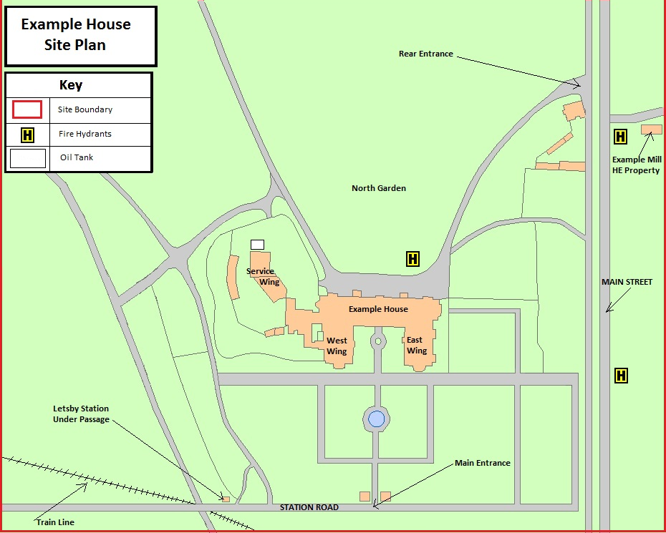

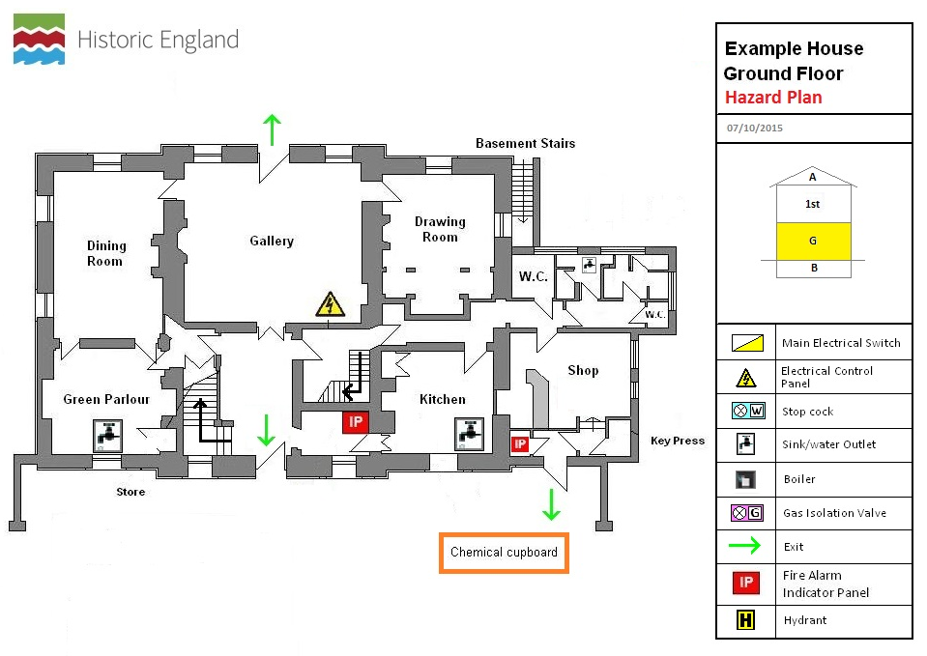

11. | Salvaging Objects
11.1 | PRIORITY OBJECTS  These items must be salvaged as a matter of urgency. Their presence is indicated by a red fluorescent circle adjacent to the object on display or at its storage location. Further information about these objects can be found on the following Priority Object Grab Sheets including photographs, dimensions, object first aid requirement, tips for removal (number of people required, fixings etc.) and a plan of their location.
 | Object type | Object description | Floor | Location
11.2 | Other Objects  After the rescue of priority objects, other items should be salvaged on the basis of how badly damaged they are and how quickly they are likely to develop mould. The salvage strategy will be developed by the Emergency Coordinator and the Salvage Manager based on the type and scale of the incident.
11.3 | Challenging Objects
Some of the objects in your collection may be challenging to salvage. Reasons for this include being very heavy, very fragile or containing hazardous materials. The Priority Object Grab Sheets (ref. below) will include information about these issues but for non-priority objects you might consider some form of marking system/ key that warns people about the challenges associated with that object.

You should also inform the Fire Service of any hazards present in objects. Further information can be found in the Museum of London’s comprehensive eTool ‘Hazards in Collections’.

Use this section to describe the challenging objects in your collection and the hazards that are present.

12. | Priority Object Grab Sheets
Priority Object Grab Sheets which could be based on the Historic England model should be inserted here.

It’s a good idea to include your Grab Sheets in your plan but to also create separate loose laminated copies stored in a file that can be handed to the fire brigade/ salvage team. These could be stored in room files or the salvage kit for the relevant area.

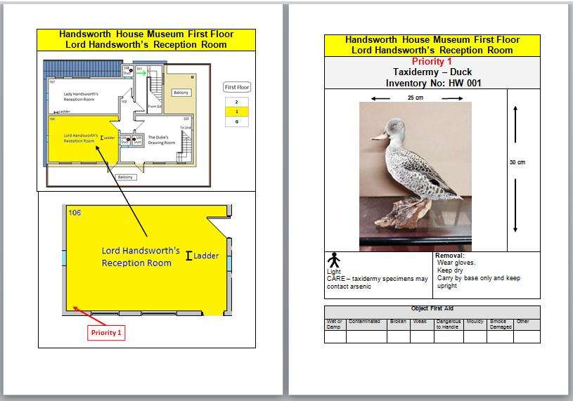

13. | Risk Assessment Form for Emergency Situation (all forms included in Appendix 1)
 | This form should be completed by the Emergency Coordinator and/ or the Building Recovery Manager before beginning the salvage operation. It may be conducted verbally and then written up immediately afterwards, as salvage begins. Salvage should not begin until adequate safeguards against hazards have been put in place. This form should be reviewed by [date] and retained.
 | Work area and/or activity
 | Date
 | Person(s) responsible for this assessment
 | Reason for this risk assessment |  |  | Salvage after Fire  Salvage after water-damage  Salvage after explosion  Other (specify)
 | Recommended review date
 | 1. Hazard Category
 | Select the most appropriate category for the activity you have identified.
 | Manual handling |  | Falling debris |  |  | Poor lighting
 | Fall from height |  | Hazardous substance |  |  | Contaminated water
 | Slip/ fall |  | Mould spores |  |  | Airborne particulates
 | Water on floor |  | Broken glass, sharp edges |  |  | Live electricity
 | Others (please specify)

2. Who is at risk?
Identify the people who are at risk from this hazard (e.g. employees, lone workers, visitors, workers other than employees, general public and volunteers. Identify and particularly vulnerable groups; such as workers with bad backs or conditions such as asthma).
3. Risk Assessment
Assess the level of risk – multiply the probability of each hazard to cause harm by the worst possible severity of injury/ damage. Action will be required for results of 2 or higher e.g. cuts from broken glass = probability 1 x severity 3 = 3
Existing control measures – what controls have been implemented to mitigate hazards?
Are these control measures adequate to contain hazards yes/ no (delete as appropriate). If you answered ‘no’, what additional controls are required to control the hazard/s?
Signature ………………………………………………………… Date…………………………………………….

14. | Inventory of Salvaged Objects/ Damage Record Form (all forms included in Appendix 1)
 | All objects salvaged from the museum should be recorded on the form below. Where a number of objects are salvaged and placed in a crate, it might be easier to record all the contents of the crate on one form to save time. The form can be adapted as necessary. There is quite a lot of information to record on this form in an emergency situation – you might prefer to evacuate objects safely and then complete the form off site. A simple list could record what objects have been removed and their new location in the first instance. You might also find it helpful to photograph or film the salvaged objects.
 | Object type | Ref. no. | Object description | Priority Object | Floor/ room recovered from |  | Type of damage | Treatment needed | Crate? Wrap?  Ref. no. | Moved to  (location)
15. | Incident Assessment Form (all forms included in Appendix 1)
 | This form should be completed by the Emergency Coordinator and/ or the Building Recovery Manager as soon as possible after the incident has occurred.
What is the nature of the damage?

Fire/ smoke, water, sewage, vandalism, other

 | When did the incident happen?
Which areas are affected?

Check entire building

What types of object are affected?

Are priority items involved?

What are the environmental conditions?

What possible health and safety issues are present?

How much material is affected?

Number of boxes/ metres of shelving etc.

How extensively has water penetrated into cabinets/ boxes?

Is there power/ water/ heat?

Is our emergency kit accessible?

Are any areas of the building in a condition to open?

16. | Salvage
The aim of the salvage operation is to recover collections, furniture and equipment from the affected areas; take them to a pre-arranged ‘salvage recovery area’ and provide conservation and treatment for damaged materials. Salvage can usually only begin once the emergency services have given museum staff and volunteers permission to re-enter the building.

In the event of an emergency; the area that would be used for placing and treating salvaged collections would be INSERT NAME.

If the museum was to be closed for a considerable period of time and the collections needed to be stored off-site long term then temporary storage would be arranged with INSERT NAME.
16.1 | Documentation
During salvage operations it is essential to keep track of all objects and to ensure they remain secure. Documentation is therefore important but should not delay removal or first aid treatment of objects.

As soon as practical a person or persons should be appointed to undertake documentation following the steps in the flow chart below.

Object receives first aid Treatment

Treatment
Required

Object
Assessment

Object
Removal

Documentation
And labelling
Treatment
Not
Required

Storage
Packing or
Further
Treatment
16.2 | Priority Objects
 | The highest priority objects were identified in [reference] and each has an individual Priority Object Grab Sheet [reference] which must stay with the object; the movement of these objects should be recorded on the ‘Inventory of Salvaged Objects’ sheet [reference].

16.3 | Other Objects
 | After removal and documentation of priority objects, the ‘Inventory of Salvaged Objects’ sheet [reference] can also be used to record what other objects have been removed, where they have been stored and/ or if they have been sent for further treatment.
16.4 | Labelling Objects
 | Identification labels with the object’s reference number should be attached to larger items of, in the case of items crated, the number of items in the crate; their reference numbers and the room they were salvaged from. Attach labels to objects by tying on with cotton tape. NEVER attach adhesive stickers directly to an object
16.5 | Security
Decide what security measures are needed at the earliest opportunity. The immediate salvage scene is likely to be chaotic, and is the most vulnerable to opportunist theft.

Wherever possible choose a salvage area that has the following features:

Accessible from the scene
- Naturally occurring boundaries e.g. fences or walls
- Is easily overlooked
- Is away from footpaths
- Is away from planting or other features that might allow a thief to approach unseen

Taping off a secure area with only one entry point, to deposit removed objects, will help identify interlopers. Anybody not known or easily identifiable and any suspicious activity should be challenged.

The further movement of objects to a triage and treatment/packing area can be more easily controlled and all persons working in these areas should be reminded of their security responsibility by the Building Recovery Manager.

If there are sufficient people, one should be appointed to supervise the secure salvage area and help ensure security.

Staff should also be alert to the possibility of people entering the building, particularly if there are some parts unaffected by the incident but have un-secured entrances.

If objects are to be transported, they need to be logged on at the site and off at their destination using an appropriate member of staff, volunteer or trustee.

High value priority objects may need to be accompanied during transport and the security of the storage facility should be assessed before entrusting the objects to a third party.
16.6 | Salvage Kit
 | The museum’s salvage kit is located INSERT LOCATION and contains AMEND LIST AS APPROPRIATE
 | Contents | Ideal quantity | Actual quantity
 | Head torch
 | Torch (rechargeable)
 | Safety helmets (check the expiry date)
 | Dust masks FFP1
 | Nitrile Gloves
 | Safety goggles
 | First Aid kit
 | Polythene sheeting
 | Crowbar
 | Wrench
 | Rope
 | String
 | J cloths
 | Heavy duty bin bags
 | Small polythene bags
 | Sponges
 | Paper towelling
 | Bubble wrap
 | Notepad and pencils
 | Scissors
 | Masking tape
 | Tie-on labels
 | Cotton tape
 | Marker pens
 | Hammer
 | Screwdrivers
 | Duct tape
 | Acid free tissue
 | Absorbent cushions
 | Bulldog clips
 | Copy of Emergency Plan summary
 | Copies of all the forms to be completed in the event of an emergency (Appendix 1)
 | Further salvage equipment and materials will be purchased or borrowed at the time of the emergency
17. | Local facilities and sources of equipment insert local contacts etc.
 | Freezing facility (cold store)
 | Van/ truck hire
 | Dustbins/ plastic crates/ trays/ binbags

 | Tarpaulins & plastic sheeting (heavy builders grade)
 | Wooden pallets
 | Portable generators
 | Emergency lighting systems/ heavy duty extension cables
 | Pumps
 | Wet and dry vacuum cleaners
 | Heaters
 | Dehumidifiers
 | Other tools/ plant
 | Council depots
 | Emergency sorting/ salvage area
 | Temporary storage area
18. | National salvage suppliers and contacts
 | Insert list of suppliers/ contacts
19. | Handling and treating objects
19.1 | Handling and moving museum objects
Handling museum objects can, if inappropriately done, result in damage both to museum objects as well as to staff and visitors. However the risk of damage can be minimised with careful handling. Before handling or moving items consider the following points:

Why move objects? Is it necessary?

What is the object(s) like?

- Size - large or small
- Weight - heavy or light
- Strength - robust or fragile
- Shape - simple or complex
- Stability - top heavy or stable
- Protection - packed or unpacked

- Are there any fragile surfaces which need protecting e.g. flaking paint
- Is there any damage such as cracks or chips, which may weaken the structure?
- Are there any repairs (these may be well concealed) which may fail?
- Are there any strong points by which the object can be handled, or weak points which should not be used to handle it?

How can I safely move it?

There are different ways in which items can be moved. To choose an appropriate one consider the following:

 | People | How many are needed? Be realistic about this and don’t underestimate whether you need help and, if so, how much. Where more than one person is involved, good teamwork is necessary. Larger projects should have a designated supervisor.
 | Protection | Will the object(s) need to be wrapped or packed and if so what materials are suitable for this?
 | Contact | Is it to be carried in the hands or in a container?
 | Equipment | Is mechanical equipment (e.g. a pallet truck) or manual equipment (e.g. picture slings) required? Have we got this equipment or will I need to buy / borrow / hire it?
 | Transport | Is powered (e.g. van) or manually propelled (e.g. trolley) transport necessary? Make sure any transport is large enough for the objects.
 | Route | Is this a clear route or will special modifications be needed e.g. taking doors off hinges, building a ramp over steps? Plan the route, if necessary walk it through, make necessary arrangements like gallery closures and work with any other people involved to keep them informed of what’s happening.

How can I reduce risks to objects during handling?

Wear gloves to protect the object from the oils and sweat on your skin as this can damage them. Gloves can also help to protect you from sharp edges or contaminants such as mercury or pesticide treatments. Gloves are available in many materials so choose one to suit the nature of the job and the type of items being handled. Ensure gloves are clean and change them when they get dirty.

Pack items to prevent them from moving around in boxes or containers when being moved. Larger items may need protective covers.

Lifting objects on your own, you should place one hand underneath it and one around it to support it. You can cradle it against your body but beware dirty clothes, jewellery and buttons on clothes which may scratch or catch on it. Never lift something by handles or knobs as these are often the weakest point. If two or more people are lifting an item together, nominate a lead person who gives instructions, clearly explain what the plan is before you all start and think about choosing people matched in height and strength if possible. When using equipment, read instructions carefully first.

How can I reduce risks to people during handling?

- Involve all affected staff.
- Close galleries or public areas to keep visitors out of the area if necessary or move things during museum closing hours.
- Ensure correct safety gear eg safety boots, and equipment is used where necessary.
- Keep equipment maintained and checked and ensure staff are trained how to use it correctly.
- Allow enough time so you aren’t rushing to get something done.
- Keep access routes clear of hazards.
- Ensure you can safely see where you are going when carrying something

If an object is damaged or dropped during handling, move people away from the immediate area and carefully brush up all pieces into a polythene bag, or envelope (preferably acid free). Larger pieces can be wrapped in acid free tissue. Label the bag with the accession number and description of the object, from which the pieces came. If it is a large or complex item, identify the area from which the pieces(s) became detached. Try to keep this package with the damaged object. Once broken pieces become separated from the parent object, they are more likely to be lost. If necessary, call in a conservator to repair the item. Document the damage and any subsequent action taken and keep this with the object’s history file.

Handling do’s and don’ts

Do:
- Keep handling to a minimum.
- Check objects for signs of damage or previous repair before handling them.
- Think before you handle an object and be realistic about what you can manage.
- Wear appropriate gloves whenever possible.
- Separate loose pieces of objects such as cups from saucers and lids from teapots, before carrying them separately.
- Cradle objects in both (gloved) hands.
- Use boxes or trays for carrying multiple objects, or items where gloves may not be appropriate, for example, items with fragile surfaces etc. Line the boxes with a thick layer of tissue or some Plastazote
- Remove watches, jewellery and sharp objects such as keys, from your person and tie back long hair. Be aware that buttons and zips on clothing can also scratch objects or be impressed into their surface.
- Ask for help if you are unhappy about moving an object on your own.
- Plan ahead, be patient and don’t rush.
- Keep access routes and stores clear and tidy.
- Collect all pieces of objects, which become detached when handling and place in a clearly labelled bag or box to be kept with the parent object.

Don’t:
- Pick up objects by handles, knobs or rims.
- Reach over one object to pick up another.
- Carry too many objects at once.
- Leave objects near the edges of desks or shelves.
- Strain to reach objects on high shelves or lift those, which are too large or heavy.
- Assume that because an object looks robust, it is.
- Rush.
19.2 | First Aid Treatment - Air Drying
Air-drying involves objects being spread out over an area and dried through air movement or dehumidification. N.B. When using fans they should be set to COLD AIR, not heat.

This method of drying can be carried out in-house. It is cheap, but labour intensive and requires space.

Prepare Room
- Remove any wet materials i.e. stationary, boxes, curtains or carpet.
- Open windows and bring in fans to circulate air OR close all windows and use dehumidifiers. (Ensuring damp air or water is vented/ drained out of room.)
- The drying effect can be intensified with a wind tunnel, a tunnel of Correx or plastic sheeting with fans at one or both ends (Ensure air from fans is not aimed directly at fragile items.)
- Washing lines can be put up for hanging or pegging (using plastic pegs) strong, but damp sheets of paper.
- Plastic, perforated racks such as bread trays or airing racks are ideal for air drying objects as they provide support and allow airflow.

Rinsing
If the objects are heavily soiled, the worst of the dirt can be removed by brushing or rinsing off, taking care not to introduce dirt to clean areas, i.e. keep books shut.

Prepare objects
- Assess books and paper based material first. (Heavily waterlogged books should be frozen if possible)
- Treat books in the following order:
  - weak and wet books
  - weak and damp books
  - strong and wet books
  - strong and damp books
- Consider the fragility of paper and fastness of dyes.
- Support all areas of fragile items, either on a board or by holding together loose fragments with a gauze bandage.
- Remove paper clips, string or ribbon (and keep bagged and labelled) to prevent staining or stress on the object.
- Three dimensional objects such as costumes and baskets need to be padded out to their normal shape before air drying. Nylon netting can be used for this
- Books that are strong enough can be stood on their spines and the pages fanned out. Turn them up the other way after a while. See ‘Books’ sheet for other options.
- Flat items such as maps, newspapers, documents and plans can be dried flat between blotting paper, as long as the inks are not running. Change blotting paper regularly.

19.3 | First Aid Treatment - Freezing
When to freeze
- If you have a large, wet collection you cannot dry in 48 hours to prevent mould growth.
- If materials have water-soluble components such as watercolours, some dyed textiles and documents with water soluble inks.
- The freezing process can take a long time, and once frozen, you may not have access to the material until the treatment is completed.
- Some objects cannot be frozen; check sheets.

Procedure
- Books can be packed for freezing in plastic containers or cardboard boxes. The books should be packed spine down in a single layer. If there is time, wrap every second item in waxed or freezer paper to prevent the covers sticking to each other.
- Textile items can be laid out flat with tissue or freezer paper rolls in the folds.
- Ensure that freezer paper is used to separate items if you need to have one on top of another. Use long boxes or boards to transport items.
- A commercial blast freezer is ideal as it drops the temperature quickly and has a large capacity. For a small amount of material a household chest freezer with a temperature of -10C can be used (as long as it does not auto-defrost)
- After the freezer has been packed do not open until you are ready to remove the material.
- When transporting material from the freezer to the freeze drier, a freezer truck should be used.
- Alternatively there are disaster companies who will take crates of wet material for immediate freezing. These companies can also offer freeze or vacuum drying.

Once frozen the following procedures can take place.

Freeze drying
In a vacuum chamber the water is turned from solid (ice) to vapour. As there is no liquid stage ink running is minimised.

Vacuum drying
Similar to freeze drying, but the temperature in the vacuum chamber is above 0oC so there is a brief water stage.
19.4 | First Aid Treatment - Mould
Mould spores are almost everywhere and can cause a major mould outbreak on water damaged material.

Check for mould
- Mould can grow in less than 48 hours.
- Mould can be many different in colours.
- Check if the material feels damp and/or there is a mouldy smell.
- Dirt, dust, stains and cobwebs can look like mould, but in the early stages of growth, mould appears as a fine web of filaments (hyphae). In later stages, the mould develops a bushy appearance; the fruiting bodies containing spores can be seen under magnification.
- Test by brushing with a pony hair brush to see if the mould is dry and powdery (dormant) or soft and smeary (active). Active mould will continue to grow and damage collections. Dormant mould will cause no further damage unless an increase in relative humidity to 70 – 75% or more causes dormant spores to germinate and the mould to become active again.
- Foxing on paper is a closely related phenomenon that can be confused with mould. Foxing involves various agents of bio-deterioration, including mould. Its appearance is characterised by red-brown stains in either discrete spots or irregular splotches, usually with no visible hyphae or mould structure. Like mould, it appears in susceptible papers exposed to high relative humidity.

Stop mould growth

- REDUCE THE HUMIDITY. Mould may form in an area with relative humidity of 65% if there is poor ventilation. Mould will grow and remain active when the relative humidity reaches or exceeds 70 – 75 percent.

- KEEP COOL – heat makes mould grow faster.

- DRY OR FREEZE WET COLLECTIONS. Freezing will not kill the mould but it will stop it growing until a conservator has a chance to dry and clean the material.

- USE COLD AIR FANS TO INCREASE THE VENTILATION.

- CONSIDER THE HEALTH RISKS – exposure to mould can lead to debilitating allergy even among people not prone to allergies.

- DO NOT USE BLEACH OR DOMESTIC PRODUCTS. These will cause additional damage to objects and will not keep the mould from recurring.

- If in doubt contact a conservator.
19.5 | First Aid for different collections materials
Historic England has created a series of downloadable First Aid sheets for different types of collections materials.. Include those that are relevant to your museum. It might be helpful to keep these as laminated A4 sheets for ease of use during an emergency. There are also first aid guidelines for different collections materials in the ‘Be prepared: emergency planning toolkit for museums’

The main types of collections at NAME OF MUSEUM are:
 | - Books |  | - Metal | - Photographs
 | - Ceramics & glass |  | - Natural History | - Plastics
 | - Furniture |  | - Paintings | - Stone & plaster
 | - Leather |  | - Paper | - Textiles
 | The following are the First Aid sheets for each of these insert sheets here
20. |  | Guidance – Entering a Flooded Building in Safety
A building damaged by rising floodwater is likely to be a dangerous place.

Before entering a flooded building you must consider:
Electrical hazards
Structural hazards
Hazardous materials
Bacteria and viruses
Ventilation

- Electrical hazards
If water has come into contact with electrical circuits, and especially if the water has risen above electrical outlets, arrange for a competent person to turn the power off at the main breaker, or fuse, of the service panel.
Do not enter if you cannot arrange to safely get a competent person to the electrical components to turn off the power or if there are any safety concerns in relation to the circumstances of the incident. Ensure only a qualified and competent person turns the power back on.

- Structural hazards
Never assume that water-damaged structures, particularly ceilings or cellars, are safe. If in doubt, DO NOT ENTER. Leave immediately if shifting or unusual noises signal a possible collapse.

- Hazardous materials
Damaged building materials may contain asbestos, lead-based paint or other harmful residues. You must ensure a Risk Assessment is undertaken by a qualified and competent person, before disturbing suspect material. Precautions must then be taken to prevent exposure. Floodwaters can contain hazardous materials such as pesticides, fuel or spilled chemicals. Do not enter if in doubt.

- Bacteria and viruses
Microscopic organisms, particularly those from sewage, can be found in mud or sediment left by floodwater. Appropriate PPE must be worn at all times to prevent illness.

- Ventilation
Never use a generator pump within an enclosed area as there is a danger of serious injury or death, due to carbon-monoxide poisoning. Generators must only be used by competent persons, fully trained to operate them safely.
 |  | N.B. The Risk Assessment of Threats identified this type of flooding as highly unlikely at NAME OF MUSEUM

21. | Guidance - Spillages
It is essential that you attend to any spillage as soon as possible. The level of response will depend on the nature of the spill and will therefore be site specific. The following should be considered:

Immediate response:
- Identify what has been spilt and assess the risk to health
- Decide quickly whether expert help is required or if the situation can be dealt with in-house using an appropriate spillage kit.
- Move people (including yourself) to a safe distance away from fumes etc.
- Cordon off the area to prevent further exposure to people
- Eliminate ignition sources
- Ventilate the area by opening doors and windows

Clean Up
- Decide on a plan of action
- Only deal with the spillage if you can identify the substance and know how to deal with it safely.
- Refer to the Hazard Data Sheets for the substances involved.
- Assemble proper materials and equipment for the clean-up
- Put on suitable Personal Protective Equipment to minimise exposure e.g. respirator, eye protection, overalls, gloves.
- Contain the spill by absorbing liquids with a suitable absorbent material or neutraliser.
- Prevent further spread, particularly into drains and/or watercourses.
- Correctly dispose of the spilt material and any clean up material using a specialist disposal firm if necessary.
22. | Guidance – Pandemic
As a result of the Covid-19 pandemic, museums should also include a section in their Emergency Plans that provides guidance on the procedures for entering lockdown if this is necessary in the future. This should be based on the lessons learned from your experiences of the Covid-19 lockdown and cover buildings, grounds, collections (including loans), insurance, security, staff and volunteers. The situation can change rapidly during lockdown so a flexible and responsive approach is essential. Take into account disruptions to supplies of materials and equipment during lockdown.

Risk assessments should also be updated. The biggest risks during lockdown are likely to be poor environment, pests and security breaches.

Reflecting on and reviewing your experiences and lessons learned during lockdown should help you to develop your procedures. Museum Development East Midlands has produced the following list of lessons learned that has been drawn together from discussions with museums during the lockdown period. It is by no means an exhaustive list but can be used as a starting point for discussions within your organisation. The list has been arranged under the three areas of the Accreditation Scheme.
Organisational Health

Wellbeing
- People need opportunities to ‘see’ each other, share experiences, offer support and seek advice.
- It’s important to create opportunities to check staff/ volunteers’ health and wellbeing during lockdown
- Consider the issues around reintegrating staff who have been working throughout the lockdown and those who have been furloughed.
- Some staff will struggle to return if they have childcare or carer responsibilities, if they become ill or if they work for a local authority and have been redeployed during lockdown.
- Work patterns will need to be flexible during lockdown, particularly where staff need to balance home-schooling, childcare, caring or other responsibilities with work. It is not essential for people to work traditional office hours when working from home.

Communication
- Strong leadership is really important and there needs to be effective communication between the Board and staff in independent museums.
- Leaders need access to a professional support network.
- It’s really important to keep volunteers involved with the museum during lockdown.
- Effective systems for communicating with volunteers need to be in place – particularly for those volunteers who don’t have internet access at home.
- How will you keep staff and volunteers informed of developments during lockdown? (e.g. email updates, newsletters, Zoom meetings, telephone calls)
- Meetings could be via Zoom, whilst taking a distanced walk or outdoors (also at a distance). Some sites have been using their courtyards or grounds to do this, placing chairs at least two metres apart.

IT
- Sorting out the IT so that staff and volunteers can work from home is vital and ideally this should be in place for everyone going forward and in the event of future lockdowns.
- There needs to be a plan for staff who can’t work from home because they don’t have the technology or their current role can’t be undertaken through home-working. (Can they do something else and what are the implications of making significant changes to someone’s job description?)

Managing Collections
- Need an agreed system for on-site checks with associated resources/ training if these are to be undertaken by non-collections staff. MDEM in partnership with Collections Trust, Museum of London and SWMD has created a Museum Site Visit Template Checklist that you can adapt and use for this purpose.
- Create guidelines for ‘putting the collections to sleep’ when closing the museum including: covering items on open display or moving them into the store (record object movement), close shutters, blinds etc, check that cases and stores are locked and keys kept safely, ensure alarms and CCTV are working, maintain environmental monitoring and control measures, insect pest traps.
- Schedule regular condition checks of high and medium risk collections if possible – provide guidance on which objects are a priority and what to look for.
- Would it be best to move some objects to a safer place off-site during future lock downs? This could be because of security or environmental concerns.
- Consider how to maintain a stable environment during closure
- Need to think about how your site will deal with donations during lockdown and develop a policy or statement to reflect this. Some sites have suspended taking in donations whilst others have a quarantine system in place.
- Does your collections development policy cover contemporary collecting related to the pandemic? Would this be through collecting objects/ archival material/ ephemera or digitally (e.g. oral history, photographs and film)?
- Good housekeeping during lockdown is essential to reduce the risk of a pest infestation. Lockdown has created excellent conditions for pests at some sites.
- Collections should not be cleaned with any sort of disinfectant, only with the approved conservation grade materials used under normal circumstances. Removing surface dust with soft brushes and a Museum Vac should be sufficient in most cases. Keeping collections in cases, draws or covered during lockdown should prevent deposits of surface dust during lockdown.
- Do your staff and volunteers have access to the collections information they need in order to be able to work from home during lockdown?
- In terms of emergency planning – don’t rely on staff/ volunteers who might not be available for evacuation and salvage

Users and their Experiences
- It’s important to keep audiences engaged with the museum during lockdown. Many sites have done this effectively through social media updates and activities on their websites.
- Try to maintain relationships with schools, colleges, universities, community and regular user groups during lockdown.
- Provide on-line resources for schools and parents who are home-schooling.

Museums should also produce a risk assessment when starting to make plans for reopening. The Museum Development Network in partnership with the Association of Independent Museums has developed a reopening guidance checklist that you can download here.

The Institute of Conservation (ICON) has produced guidance on ‘Emergency Response during Covid-19: What impact will the pandemic have on emergency plans and salvage within the heritage industry?’ and ‘Emergency Response during Covid-19: what changes should we be making to our emergency preparation and response plans’. The latter includes the following Response Flowchart
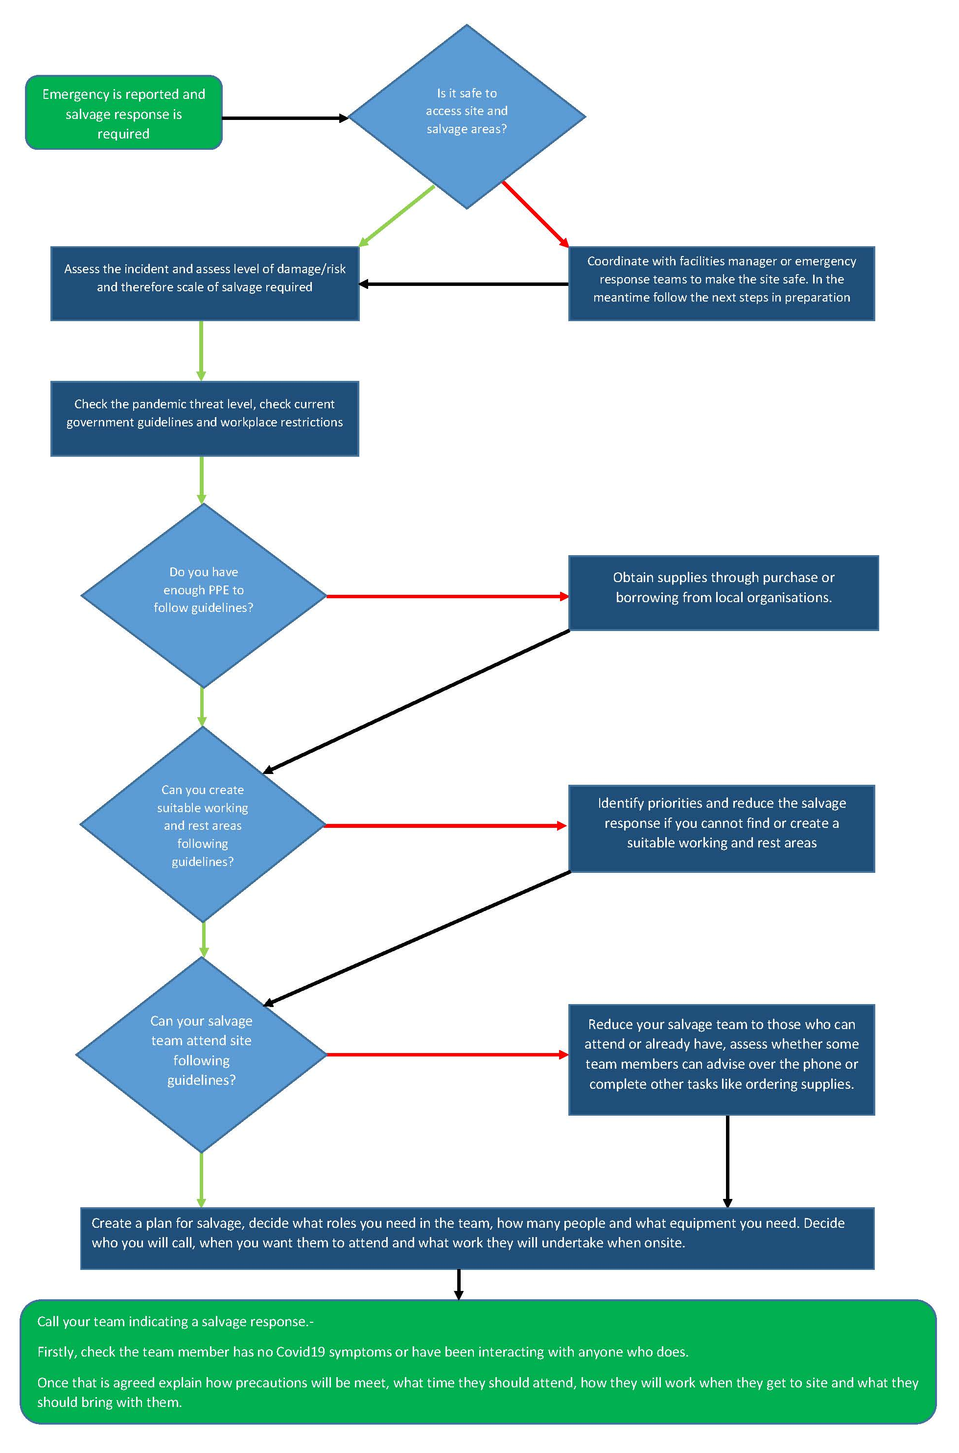
23. | Emergency Plan Review Procedure
The Accreditation Guidance (2019) states that you should review your Emergency Plan every five years (although the Spectrum procedure for ‘Emergency planning for collections’ states that this should ‘no less than annually’), and after any significant changes to buildings and contents such as a redevelopment.

You should also review you plan after an emergency/ disaster situation in order to consider how well your plan has functioned and make changes to improve its operation. This should include the date and type of emergency, what your organisation did, who was involved and lessons learned.

Plans should be updated to reflect changes in key personnel, procedures, locations and any heightened risks associated with building works or other new activities.

Guidance sheet from SHARE Museums East http://www.sharemuseumseast.org.uk/resources-2/
From Historic England’s ‘Writing an Emergency Response Plan’ https://historicengland.org.uk/advice/technical-advice/emergency-and-fire/response-plans/
From Historic England’s ‘Writing an Emergency Response Plan’ https://historicengland.org.uk/advice/technical-advice/emergency-and-fire/response-plans/
From Historic England’s ‘Writing an Emergency Response Plan’ https://historicengland.org.uk/advice/technical-advice/emergency-and-fire/response-plans/
From Historic England’s ‘Writing an Emergency Response Plan’ https://historicengland.org.uk/advice/technical-advice/emergency-and-fire/response-plans/
From Historic England’s ‘Writing an Emergency Response Plan’ https://historicengland.org.uk/advice/technical-advice/emergency-and-fire/response-plans/
From Historic England’s ‘Writing an Emergency Response Plan’ https://historicengland.org.uk/advice/technical-advice/emergency-and-fire/response-plans/

